***SMART SECURITY SYSTEM***

**WORKS DONE:**

In this project, we are developing a SMART security system for enhancing the working of watchman / security in protecting the property. For developing the system, we have used the microcontroller (Arduino UNO) to control the security system. The system automatically opening the gates while vehicle enter by sensing the distance (US sensor) and closes automatically. The main aim of the system is to detect the motion inside the registered area. For this we are using ultrasonic (US) sensor to detect the vehicle in the entry. If so, using servo motor, automatically the gates will be opened for the vehicle entry and white indication light will be on. After vehicle enters, the gates will automatically close. Inside the building (Around the compound wall), if there are any movements detected, it will be sensed by PIR motion sensor and a buzzer or LED will indicates that motions are detected inside the building.

**FUTURE IMPLEMENT:**

* Using motion sensor if any suspicious activities (from night 11.00 P.M to morning 4.30 A.M) are detected, then using GSM module, alert message is passed to respective building security and owner.
* For better security purpose developing a geo fence around that area, and placing a GPS remote to a particular vehicle. While the vehicle enters the region the doors will open.
* Developing a mobile application to control the security system from anywhere.

**IMPLEMENTTION :**

I] Structure:

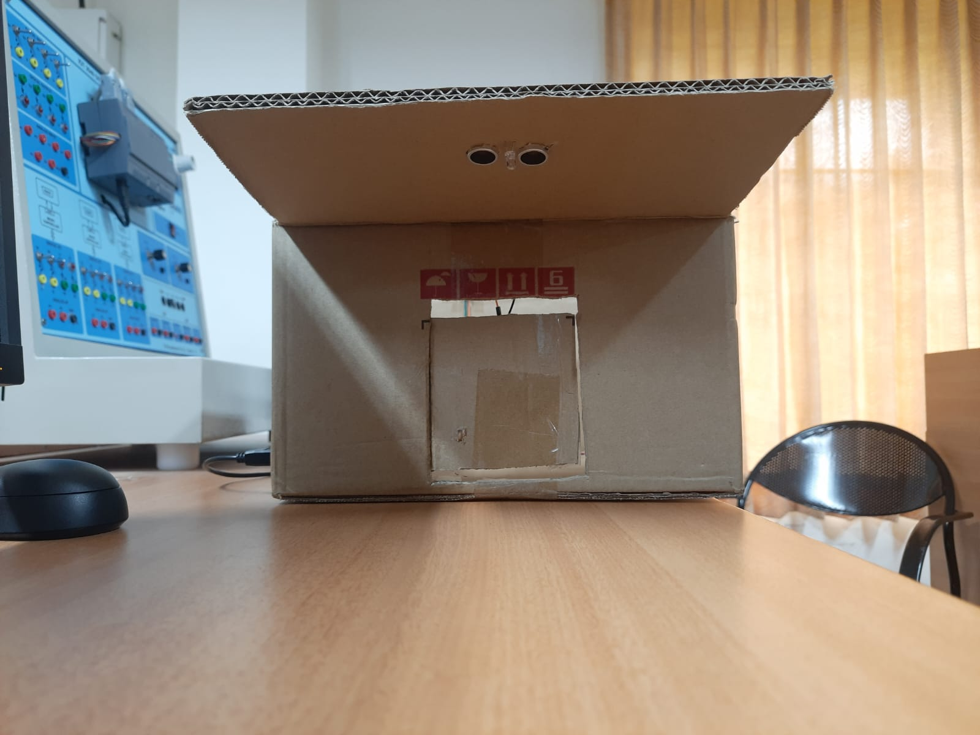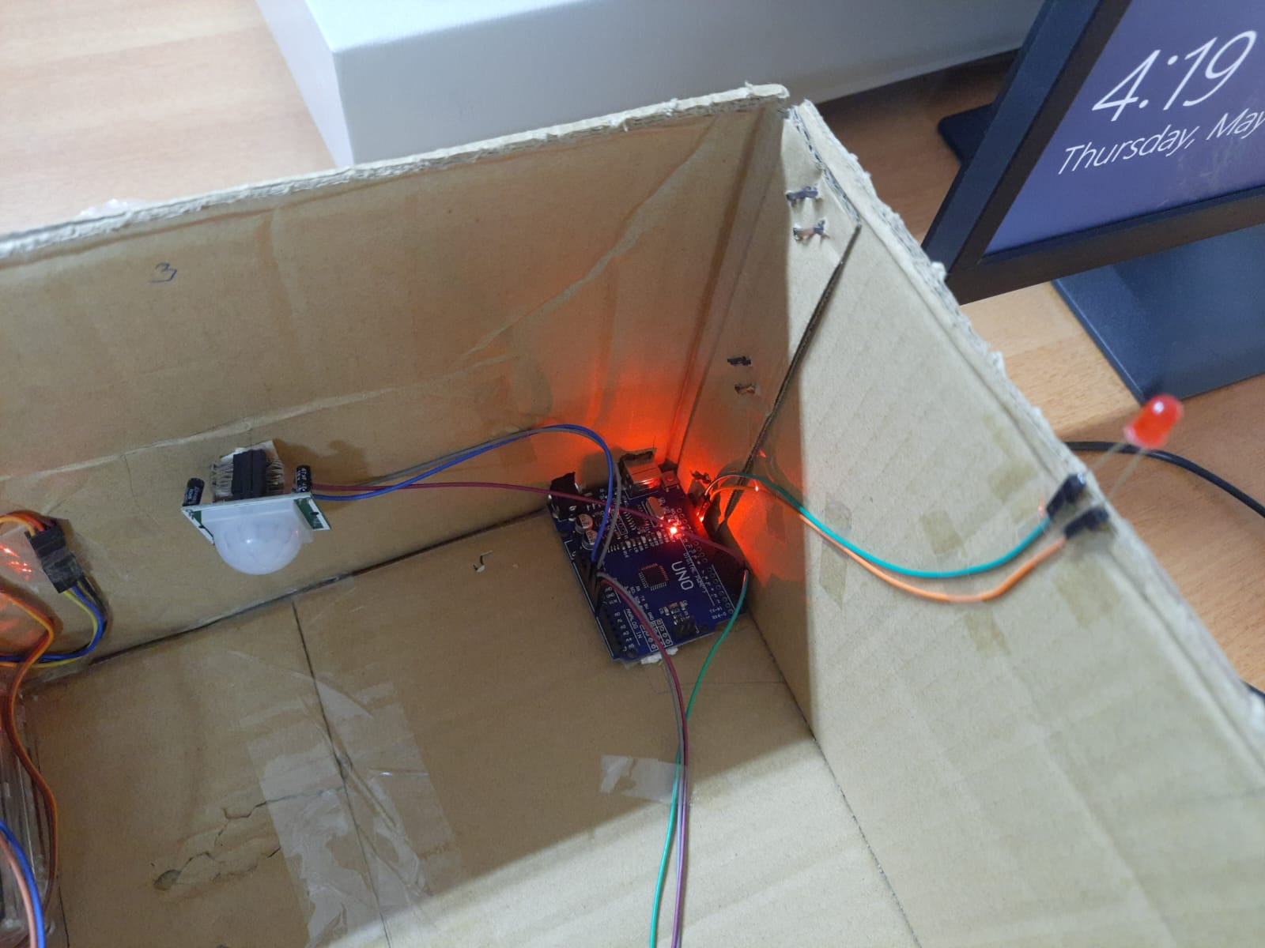

II] Automatic door opening:

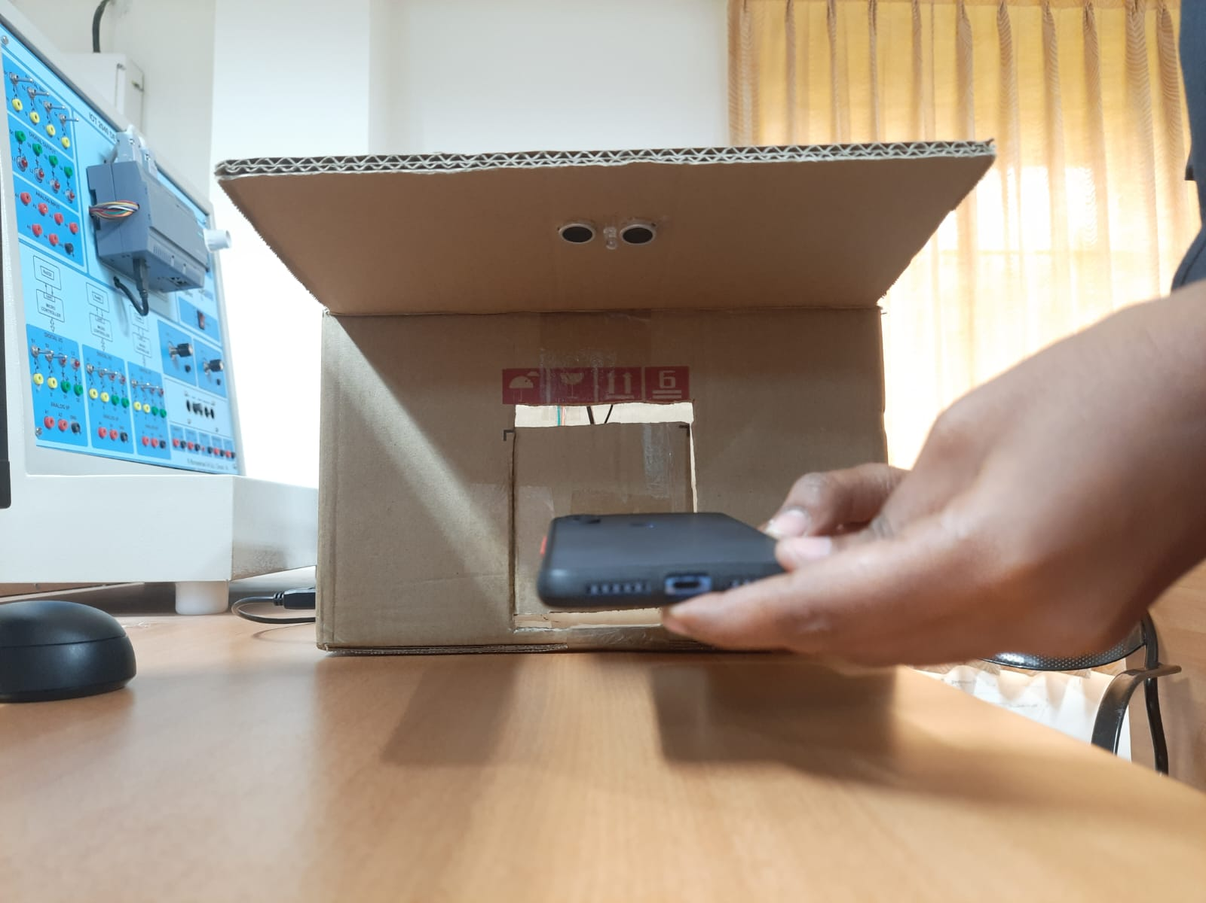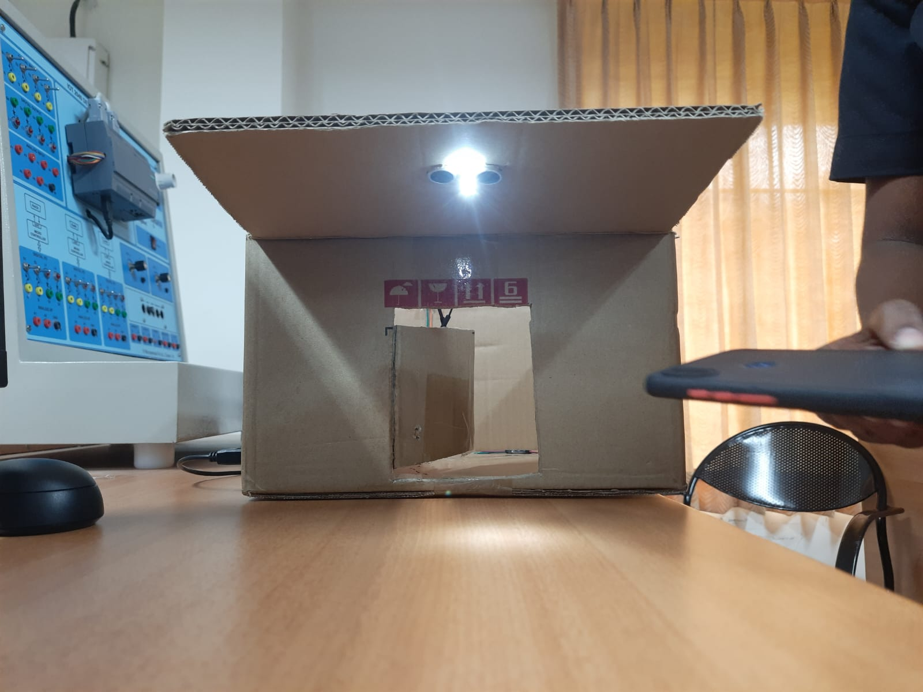

III] Motion detecting:

